# Task 3: Multiple Regression in R

This informal report contains a brief overview of the procedures and the results obtained in this third task. In this task I began by pre-processing the data and developing an exploratory data analysis to comprehend the data.

The objective of this task is to train multiple regression models on a dataset and apply the said model on a different dataset to generate predictions. Briefly, we are intended to create a model capable of forecasting the weekly sales volume in a small selection of products. As can be seen below, this nominal variable is slightly unbalanced:

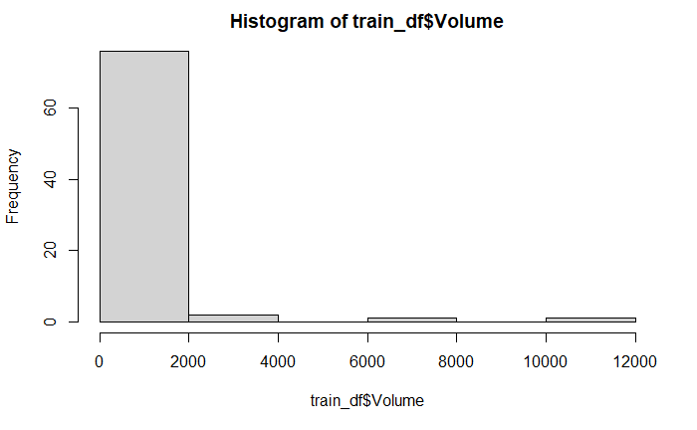

Figure 1 - Target count distribution

Both datasets (train and test) contain the same information, and the behavior of each column is similar in both the datasets. The only exception is that the target variable, Volume, has been filled by default with ‘0’ in the testing dataset. The remaining variables are valid.

In order to forecast the target, a dataset with 17 other variables has been provided. Briefly, these variables contain the information of the product type, price and profit margins, customer reviews and dimensions.

In this exercise I was asked to develop 4 models: Linear Regression; Support Vector Machine; Random Forest & Gradient Boosting. The data processing and procedure for training each of these models was identical. Before training each model I simply divided the pre-processed dataset in train and test sets (the latter contained 25% of the data). Now, I will briefly discuss each model individually below.

## Model 1: Linear Regression:

In this first model, I didn’t use any cross validation as this was just an exploratory model. The performance of this model could not capture the complexity of the target and therefore was the worse out of the 4. The main metrics can be seen in the following table:

|  |  |  |
| --- | --- | --- |
| **RMSE** | **R2** | **MAE** |
| 671.7 | 0.38 | 437.6 |

It’s worth adding that I chose the PositiveServiceReview as the correlation exploration showed that review based variables had a high correlation with the target and therefore could be more informative. Linear models, generalized linear models, and nonlinear models are examples of parametric regression models because we know the function that describes the relationship between the response and explanatory variables. This dataset is small and the data does not seem to follow the distributional requirements of parametric methods, (as can be seen in the R markdown script) the data is highly skewed and many features are categorical, not numerical.

## Model 2: Support Vector Machine:

In this second model, I utilized 10 fold cross-validation with a manually tuned grid of length size 5 on the *mtry* (number of variables randomly sampled as candidates at each split) parameter.

Once again I chose the Kappa as the optimization metric instead of the accuracy because this metric is more indicated for unbalanced datasets. After training I ran the model on the test dataset and obtained the following metric results for the model:

|  |  |
| --- | --- |
| **Accuracy** | 0.9329 |
| **Kappa** | 0.8568 |

This model provides an accuracy of approximately 94% which is pretty high. The Kappa or Cohen's Kappa is at around 86% which is quite impressive since this metric is normalized at the baseline of random chance on our dataset. This dataset has a slightly unbalanced target, therefore the Kappa value is quite different from the accuracy value. It's worth adding that if the model was trained to optimize the accuracy, the metrics accuracy and Kappa obtained would be slightly lower.

Note that many other metrics have been calculated and commented in the R notebook. Anyway, I have omitted the many other metrics from this brief summary to avoid elongating this report.

For this model the overall relative importance of the top 3 most relevant features were:

|  |  |
| --- | --- |
| **Salary** | 100.0% |
| **Age** | 55.2% |
| **Credit** | 12.5% |

Contrarily to the previous model, this one relies more on the credit features. Anyhow, it seems that this model would perform fairly well if it only had access to the Salary and Age of the customer, the importance of the credit variable is still clearly lower than the top features according to importance.

## Model 3: Random Forest:

## Model 4: Gradient Boosting:

## Model Comparison

Having created two models, it is now time to pick the one with better performance in order to create the predictions in the previously untouched dataset.

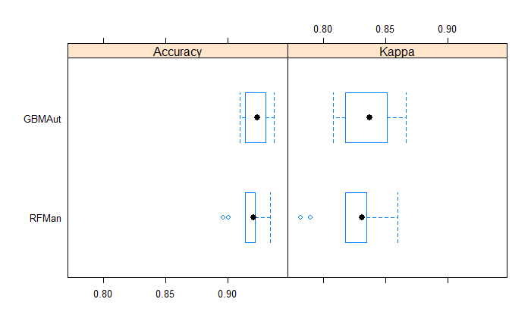

Figure 2 - Boxplot of Accuracy and Kappa for GBM and RF models

Looking at the table and boxplot of the chunk above it seems that both algorithms have a good performance in forecasting the target of this problem. However, the Stochastic Gradient Boost seems to provide a slightly better performing model as the interquartile range for both the accuracy and kappa falls is located at a higher value.

Below I have represented the predicted distribution a percent stacked barchart of the computer brand preference in the predictions and in the train dataset:

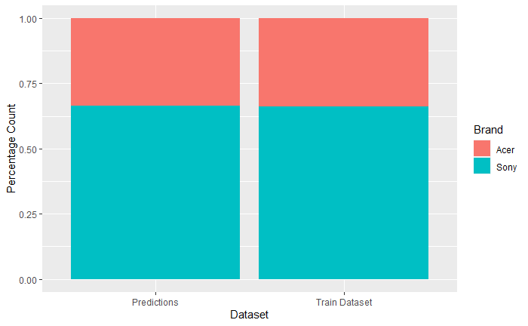

Figure 3 - Percent stacked barchart of Computer Brand for train and predictions

In the figure above I have created a chart that shows the preferences for Sony and Acer for the entire 15,000 existing customer survey. The *predictions* dataset contain the proportion of predicted computer brands on the incomplete survey and the *train dataset* corresponds to the actual proportion on the complete responses. It can be seen that this proportion is pretty much the same for both datasets, meaning that the test and train datasets contain clients with similar behaviors.

In conclusion, Blackwell's customers typically prefer Sony as their computer brand comparatively to Acer, and this can be forecast with a high accuracy.